**Streamlining Ticket Assignment for Efficient Support Operations**

**Team Id:**

**Team Members:**

**Team Leader : Abirami S**

**Team Member 1 : Abinaya G**

**Team Member 2 : Sandra Vadhani R**

**Team Member 3 : Gayathri P**

**Statement: Streamlining ticket Assignment for efficient support operations**

**Objective:** To automate ticket assignment process by intelligently matching support tickets to the right agents based on priority, expertise, and workload and improving response time

**Skills:**

**TASK INITIATION**

**Milestone 1 : Users**

**Activity 1:** **Create Users**

Open service now

1. Click on All >> search for users
2. Select Users under system security
3. Click on new
4. Fill the following details to create a new user
5. Click on submit

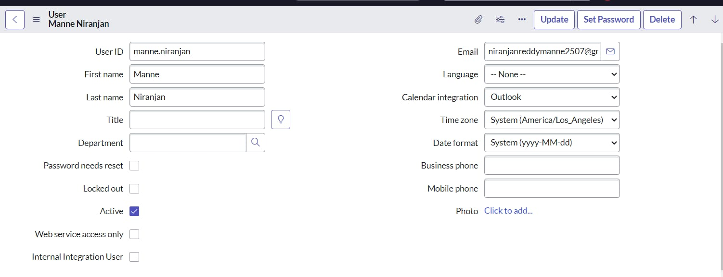

**Create one more user:**

1. Create another user with the following details
2. Click on submit

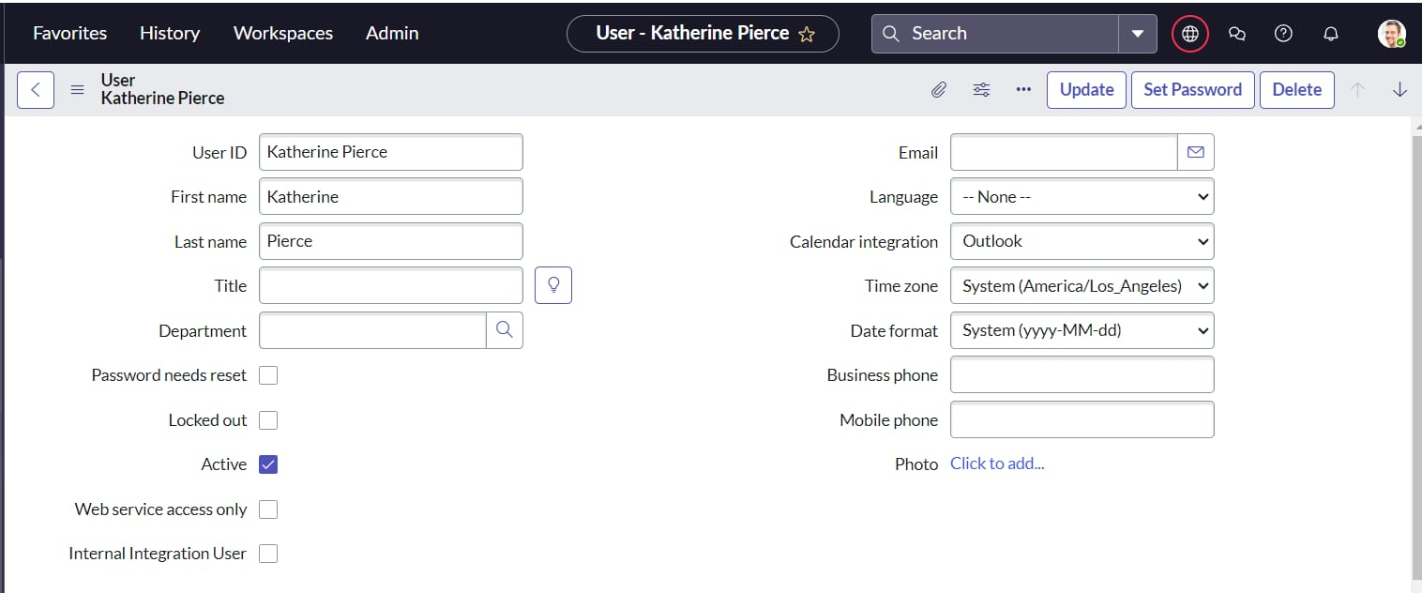

**Milestone 2 : Groups**

**Activity 1:** **Create Groups**

1. Open service now.
2. Click on All >> search for groups
3. Select groups under system security
4. Click on new
5. Fill the following details to create a new group
6. Click on submit

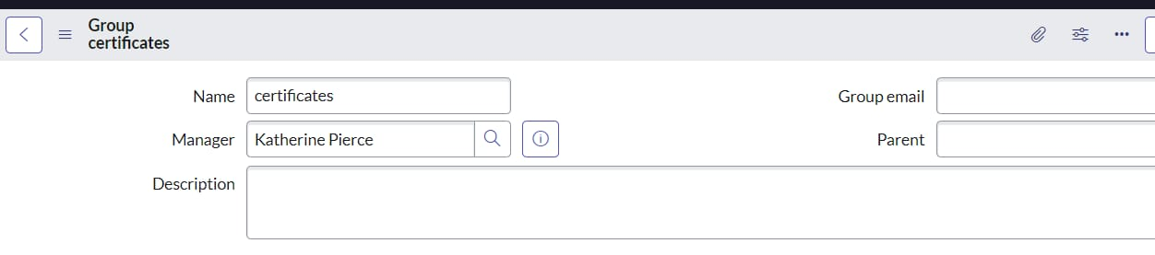

**Create one more group :**

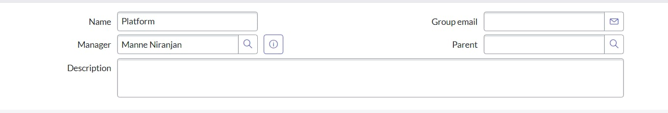

**Milestone 3 : Roles**

**Activity 1:** **Create roles**

1. Open service now.
2. Click on All >> search for roles
3. Select roles under system security
4. Click on new

5.Fill the following details to create a new role

6.Click on submit

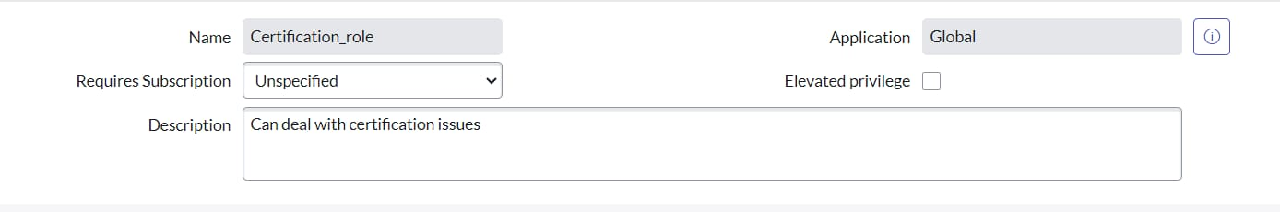

**Create one more role:**

7.Create another role with the following details

8.Click on submit

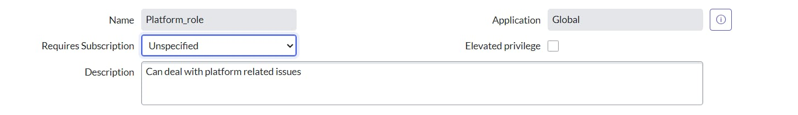

**Milestone 4 : Table Activity 1:** **Create Table**

1. Open service now.
2. Click on All >> search for tables
3. Select tables under system definition
4. Click on new
5. Fill the following details to create a new table

Label : project table

Check the boxes Create module & Create mobile module

1. Under new menu name : project table
2. Under table columns give the columns
3. Click on submit

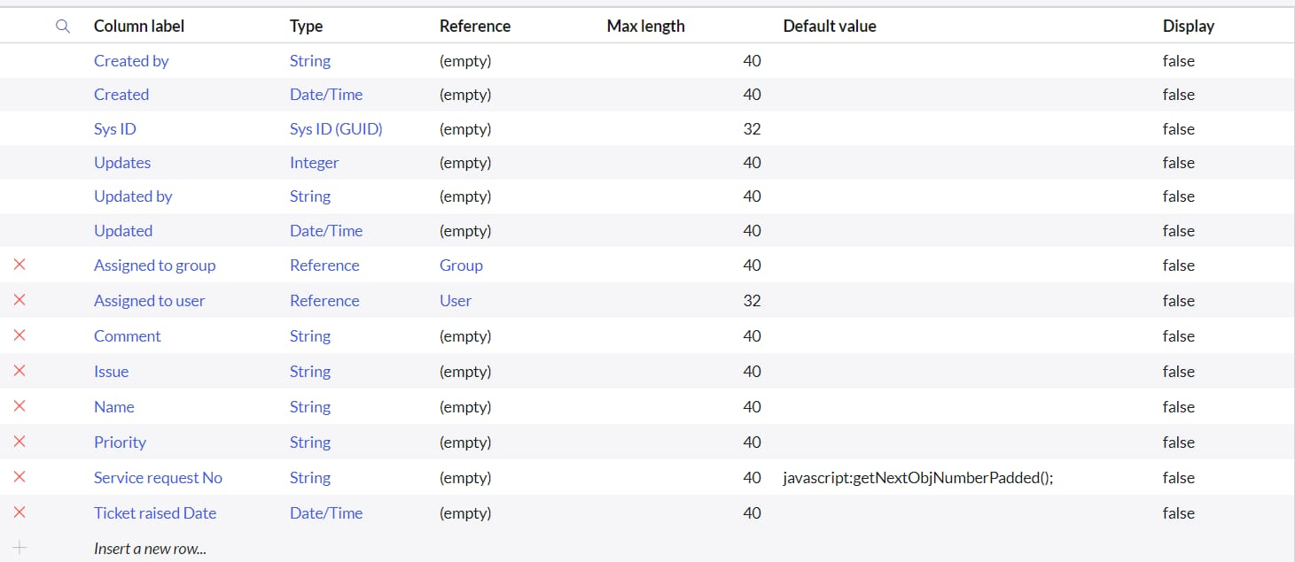

**Milestone 5 : Assign roles & User to groups**

**Activity 1 :**Assign roles & users to certificate group

Open service now.

1. Click on All >> search for tables
2. Select tables under system definition
3. Select the certificates group
4. Under group members
5. Click on edit

**Activity 2 :**Assign roles & users to platform group

Open service now.

1. Click on All >> search for tables
2. Select tables under system definition
3. Select the platform group
4. Under group members
5. Click on edit
6. Select Manne Niranjan and save
7. Click on roles
8. Select Platform_role and save

**Milestone 6 : Assign roles to table**

**Activity 1:** Assign role to table

Open service now.

1. Click on All >> search for tables
2. Select operations related table
3. Click on the Application Access
4. Click on u_operations_related read operation
5. Click on the profile on top right side
6. Click on elevate role
7. Click on security admin and click on update
8. Under Requires role
9. Double click on insert a new row
10. Give platform role
11. And add certificate role
12. Click on update

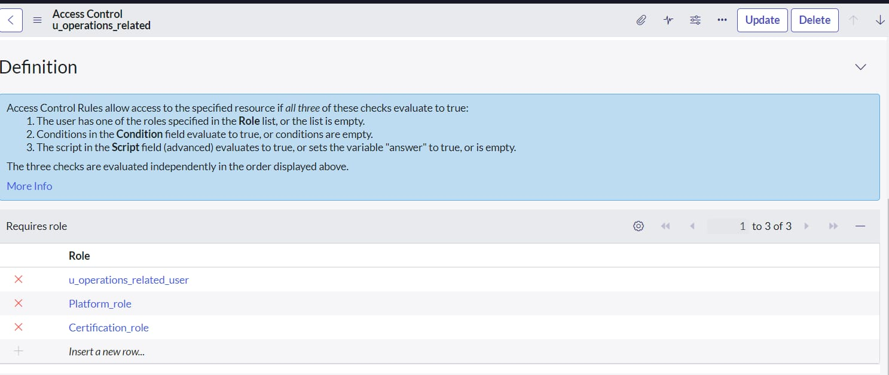

13.Click on u_operations_related write operation

14.Under Requires role

15.Double click on insert a new row

16.Give platform role

17.And add certificate role

**Milestone 7 : Create ACL**

**Activity 1: Create ACL**

1. Open service now.
2. Click on All >> search for ACL
3. Select Access Control(ACL) under system security
4. Click on new
5. Fill the following details to create a new ACL
6. Scroll down under requires role
7. Double click on insert a new row
8. Give admin role
9. Click on submit
10. Similarly create 4 acl for the following fields

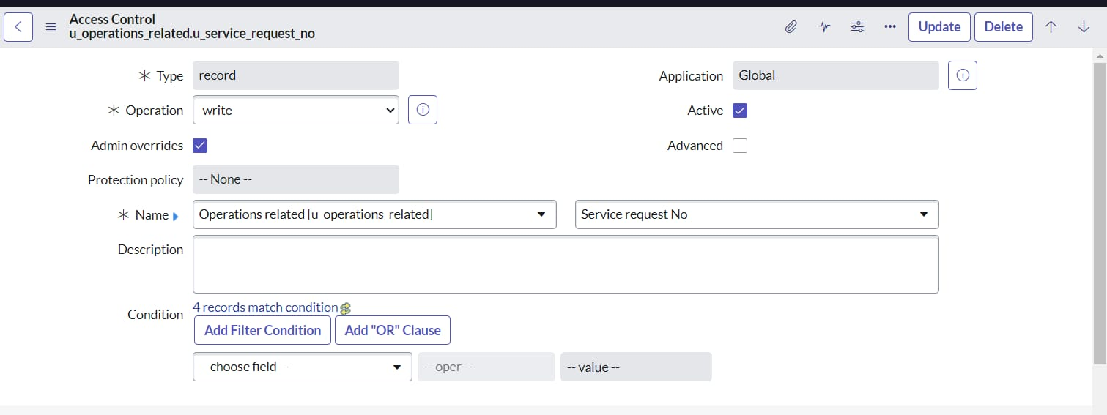

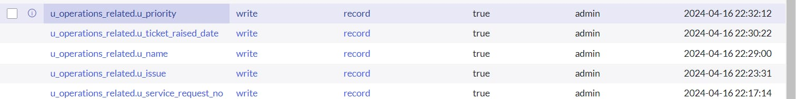

**Milestone 8 : Flow**

**Activity 1** :Create a Flow to Assign operations ticket to group

1. Open service now.
2. Click on All >> search for Flow Designer
3. Click on Flow Designer under Process Automation.
4. After opening Flow Designer Click on new and select Flow.
5. Under Flow properties Give Flow Name as “ Regarding Certificate”.
6. Application should be Global.
7. Select Run user as “ System user ” from that choice.
8. Click on Submit.

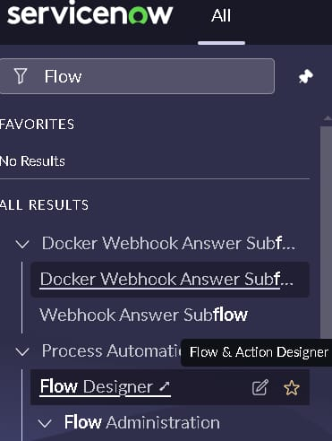

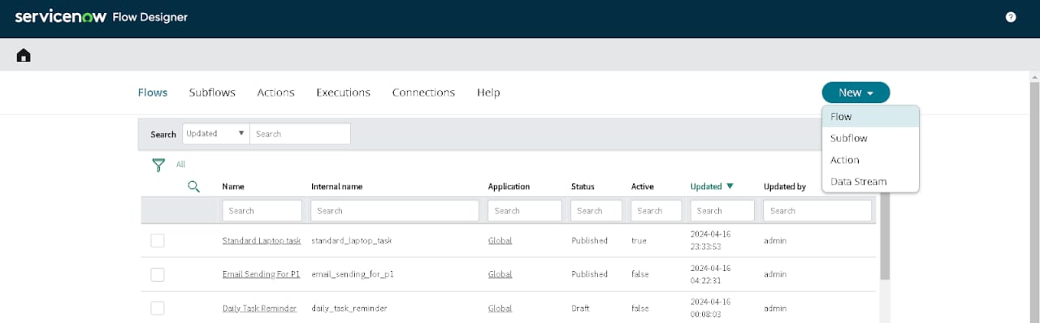

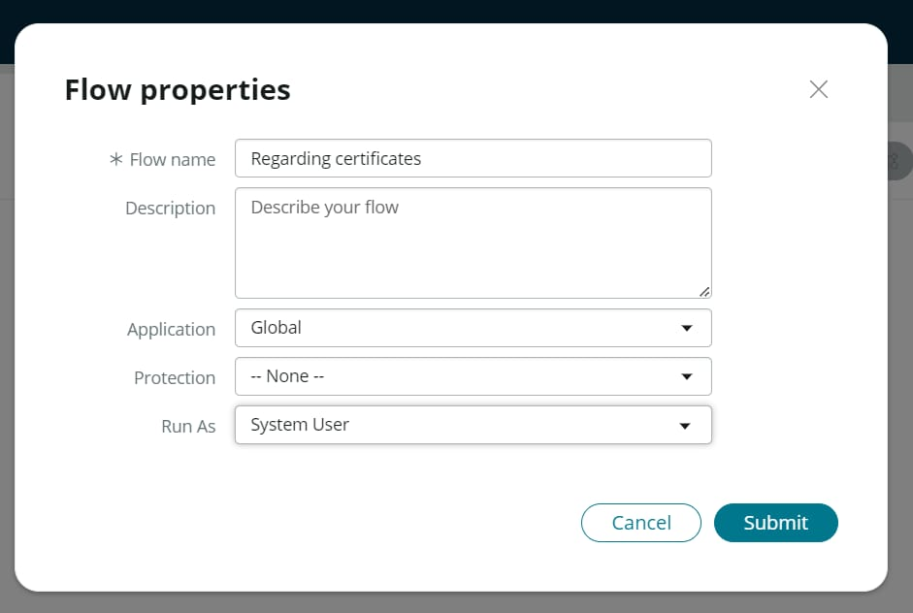

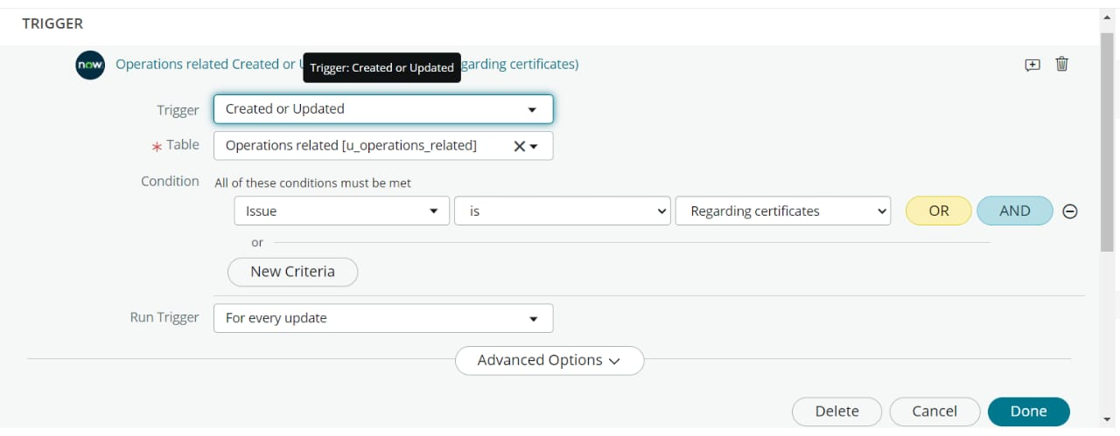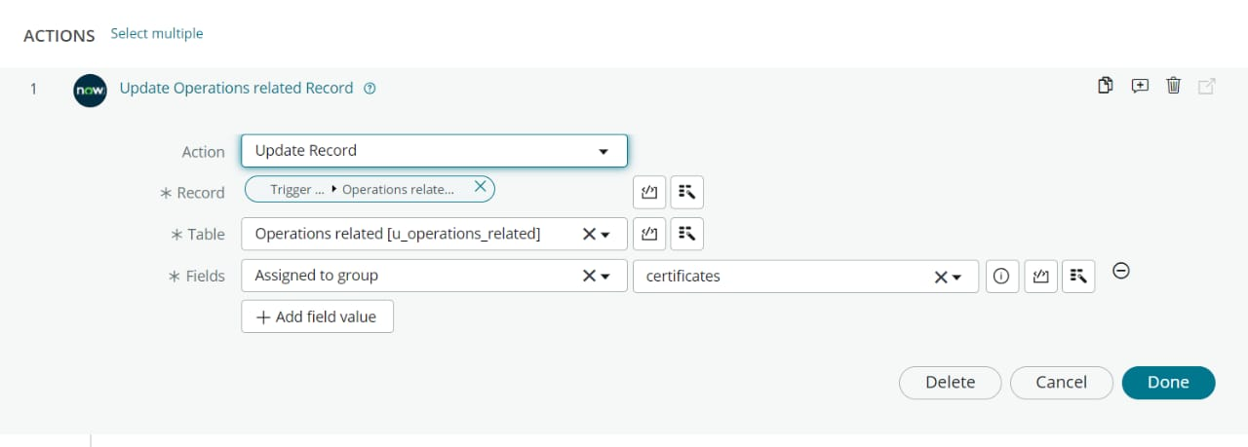

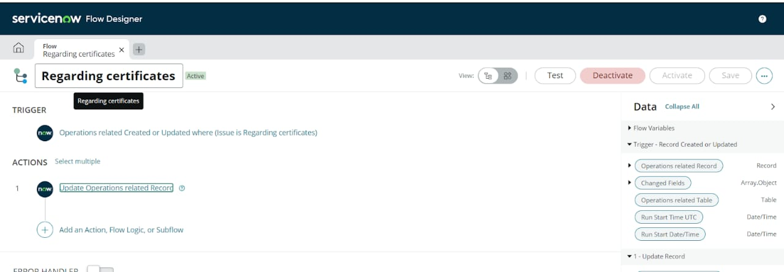

**Activity 2** : Create a Flow to Assign operations ticket to Platform group

1. Open service now.
2. Click on All >> search for Flow Designer
3. Click on Flow Designer under Process Automation.
4. After opening Flow Designer Click on new and select Flow.
5. Under Flow properties Give Flow Name as “ Regarding Platform ”.
6. Application should be Global.
7. Select Run user as “ System user ” from that choice.
8. Click on Submit.

Click on Add a trigger

* Select the trigger in that Search for “create or update a record” and select that.
* Give the table name as “ Operations related ”.
* Give the Condition as
* Field : issue
* Operator : is
* Value : Unable to login to platform

Click on New Criteria

* Field : issue
* Operator : is
* Value : 404 Error

Click on New Criteria

* Field : issue
* Operator : is
* Value : Regrading User expired

1. After that click on Done.
2. Now under Actions.
3. Click on Add an action.
4. Select action in that search for “ Update Record ”.
5. In Record field drag the fields from the data navigation from left side
6. Table will be auto assigned after that
7. Give the field as “ Assigned to group ”.
8. Give value as “ Platform ”.
9. Click on Done.
10. Click on Save to save the Flow.
11. Click on Activate

**CONCLUSION :**

The implementation of the automated ticket routing system at ABC Corporation has been a significant success. By leveraging the capabilities of ServiceNow, we have streamlined the process of assigning support tickets to the appropriate teams, addressing the challenges of manual routing, and ensuring timely resolution of issues.